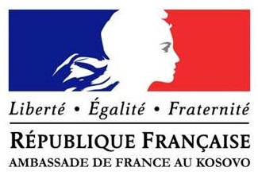

Conference on the occasion of the100 yearanniversary of the end of the First World War
“Remembering War, Peace and Reconciliation”

Agenda
14. November 2018 at the National Library of Kosovo

08.30 Arrival of the Participants (Registration)

09.00 Opening of the Conference
Introductory note by Mr. Vincent Lungwitz, forumZFD
Presentation of the Speakers

09.15 “1914 - 1918: Europe in War” (Short statements followed by an open floor discussion)

- Dr. Nicolas Ginsburger: "Toward a New World: Geopolitics of the First World War"

- Dr. Heiko Brendel: "The Trenches and Beyond: Soldiers and Civilians on the Western Front”

- Dr. Ulrich Pfeil: “Arch Enemies”, Propaganda and Perception: How did France and Germany see each other before and during the Great War?

- Dr.BujarDugolli: ”First World War in History Text Books in Kosovo, Albania and Macedonia

- Dr. Ibrahim Gashi: “Epilogue of the First World War in the Balkans”

Moderation: Mr. Vincent Lungwitz
10.45Coffee break
11.00 “Missed opportunity for reconciliation after the first World War and its consequences” (Panel discussion followed by an open floor discussion)
- Dr. Ulrich Pfeil

- Dr. Nicolas Ginsburger

- Dr. Heiko Brendel
Moderation: Mr. Vincent Lungwitz

12.00Lunch break

***
Public session (open to the media)
13.00-14:30:“Lessons learnt from the Franco-German reconciliation”.

Introductory statements (up to 10 minutes) by French Ambassador, H.E. Mr. Didier Chabert andGerman Ambassador, H.E. Mr. Christian Heldt (in French and German languages)

Open discussion with students

Presentation: Mr. Vincent Lungwitz

Language regime: English, Albanian and Serbian

Project Partners:
ForumZFD University of Pristina Young Gracanica
