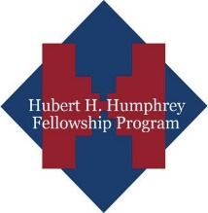
CallforApplications>>
2019-2020 HubertH.Humphrey
FellowshipProgramformid-careerprofessionals

U.S.MissionKosovoisnowacceptingapplicationsforthe2019-2020HubertH.HumphreyFellowshipProgram.Thistenmonthfellowshipprogramisofferedto
mid-careerprofessionalsworkingatthepolicylevelwhohavearecordofleadershipandacommitmenttopublicservice.FellowsarebasedatleadingAmericanuniversitiesforten-monthstopursueself-designedpro-gramstoincludeindependentstudy,coursework,andan

TheHubertH.HumphreyFellowshipProgrambringsaccomplishedprofessionalsfromdevelopingcountriestotheUnitedStatesatamidpointintheircareersforatenmonthprogramofnon-degreestudyandrelatedprofessionalexperiences.Theprogramseekstofosteranex-changeofknowledgeandmutualunderstandingbetweenAmericancitizensandtheirprofessionalcounterpartsfromUganda.SuccessfulapplicantswillbeplacedatparticipatinguniversitiesintheUnitedStatesfortheAugust2019-June2020period.

EligibleFields

Sustainable Development
a. Agricultural and Rural Development
b. Economic Development/Finance and Banking
c. Natural Resources, Environmental Policy, and Climate Change
d. Urban and Regional Planning
Democratic Institution Building
a. Communications/Journalism
b. Law and Human Rights
c. Public Policy Analysis and Public Administration
d. Trafficking in Persons Policy and Prevention
e. Technology Policy and Management
f. Human Resource Management
Education
a. Educational Administration, Planning and Policy
b. Higher Education Administration
c. Teaching of English as a Foreign Language
Public Health
a. Public Health Policy and Management
b. HIV/AIDS Policy and Prevention
c. Substance Abuse Education, Prevention, and Treatment
c. Substance Abuse Education, Prevention, and Treatment

FORINQUIRIESPLEASE CONTACT:Cultural Affairs Assistant – Education, Public Affairs Office
E-mail: KosovoEdExchanges@state.govAPPLICATIONDEADLINEIS May 31,2018
The application formisavailable onhttps://iie.embark.com/apply/humphreyfellowship2019

EligibilityRequirements
ApplicantsfortheHumphreyFellowshipmustmeetallofthefollowingcriteria:
- Kosovo citizenship
- Five years of full-time professional experience
•
- University degree
- Havedemonstratedleadershipqualitiesandarecordofpublicservice,and
•

Application/SelectionProcess
Theapplicationformisavailableonhttps://iie.embark.com/apply/humphreyfellowship2019
CompletedapplicationsshouldbesubmittedonlinenolaterthanMay 31,2018.Applicationsmustdetailthespe-

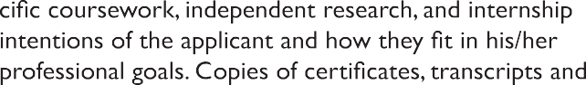
lettersofrecommendationshouldbeuploadedinapplicant’sonlineapplication.Only final nominees will berequiredtotaketheTestofEnglishasaForeignLanguage(TOEFL).

Allapplicationsarereviewedbyalocalselectionpanel;

Final selection of Fellows will be made by the J. William
FulbrightForeignScholarshipBoard.AwardsareannouncedbyMarcheachyearforFellowshipsbeginninginAugust/September.

GrantProvisions
TheHumphreyFellowshipprovides:
- Round-tripeconomyinternationaltravelforthegrantee.
- Amonthlymaintenanceallowanceandfundingforbooksandprofessionalactivities.
- Tuitionanduniversityfees.
- Limitedaccidentandsicknessinsuranceforthegranteeonly

Note:Onlyshortlistedcandidates will be notified.

